Procedure to create a Maven Project

1.create a folder
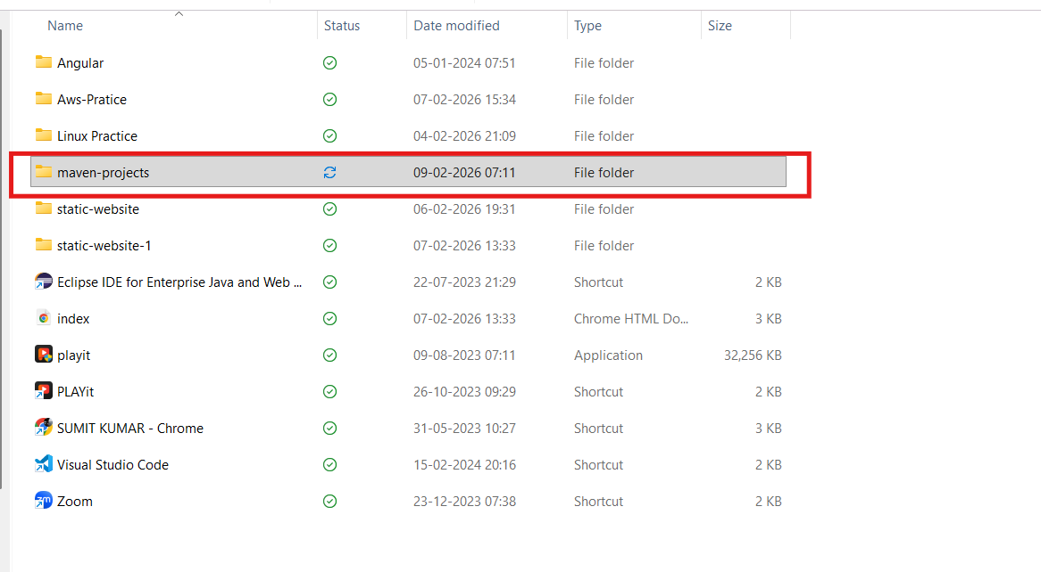
2.Go Inside the folder & open command prompt
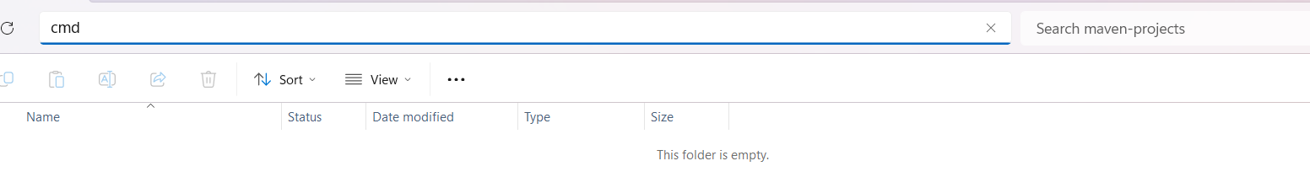

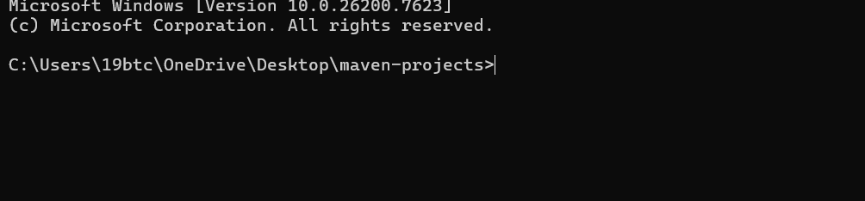

3.Go to Maven official site (https://maven.apache.org/guides/getting-started/index.html) 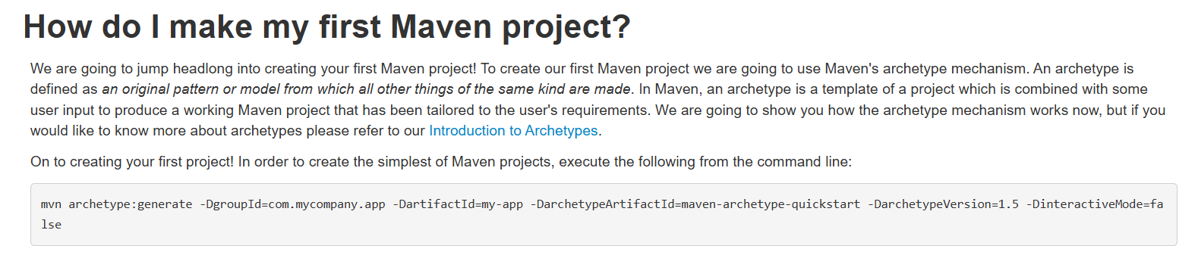

4.copy the structure

5.Built the maven project
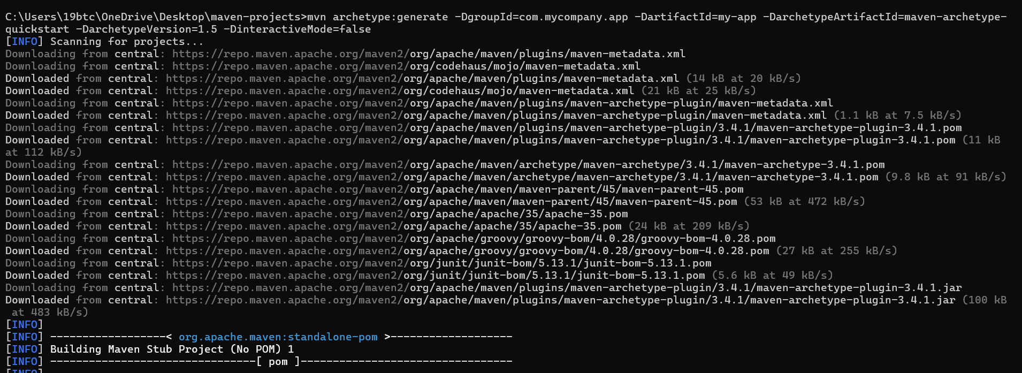
.
.
.
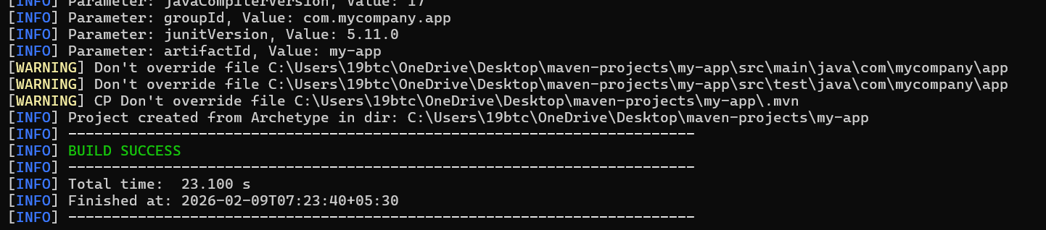

5. The Maven project folder structure has been created.
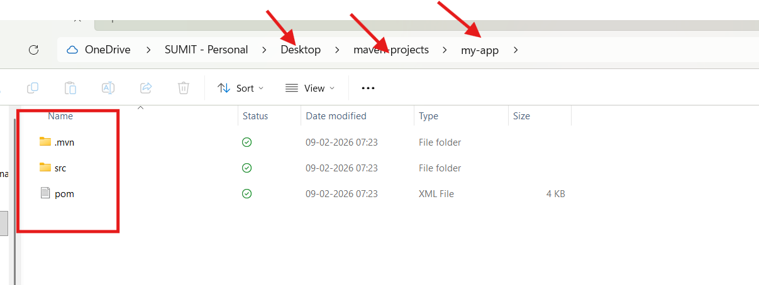
6. go to visual studio code

7.Inside VS code open the folder
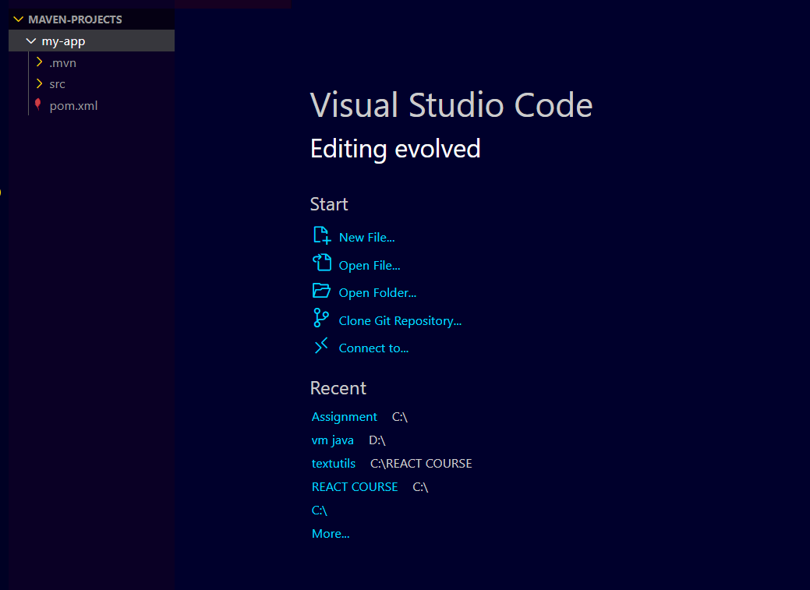
8.Developer will write the code and push the code to git As devoops Engineer our goal is to clone the code and execute the maven goals

9.Inside VS code go to Toogle Panel
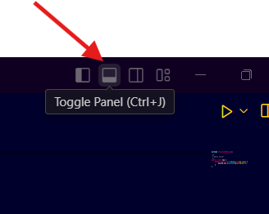
10.By default our terminal takes power shell we have to choose Git Bash
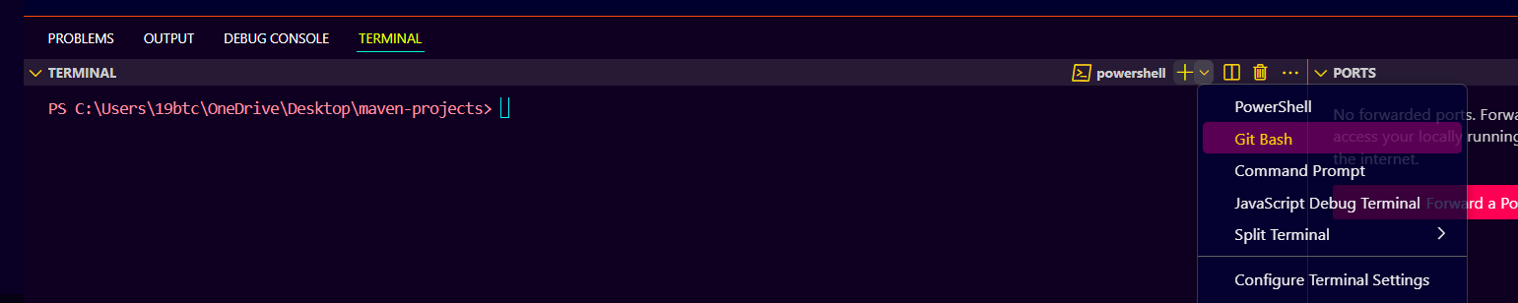
11.Every time our maven goal is to go and execute inside the project folder
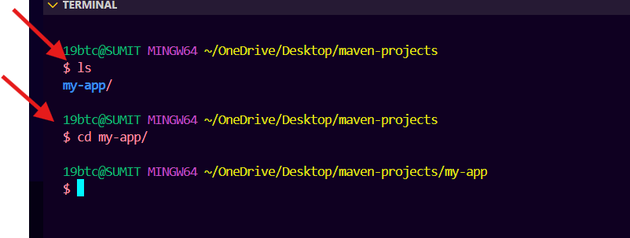
12.To see the hidden file we need to use commad ls -la

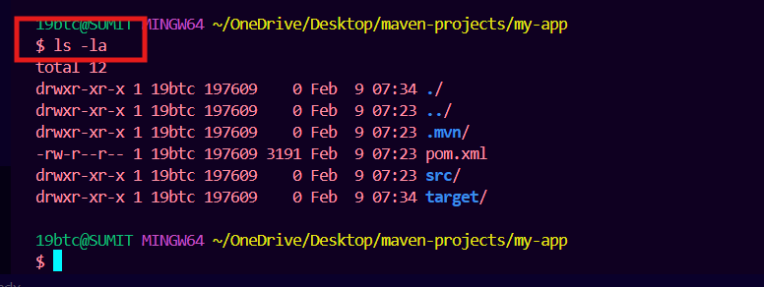

13. execute the command for goals maven goals

i)mvn clean : It will clean my mvn application
ii)mvn compile: We can compile application code (target folder)
iii)mvn test: we can test our application code
iv)mvn package : we can package our application code + dependencies

i)mvn clean : It will clean my mvn application
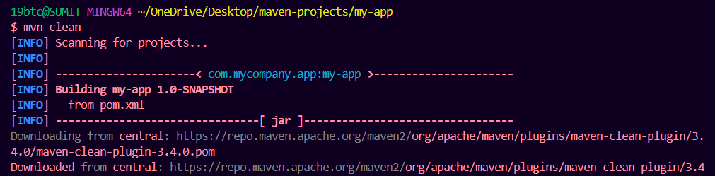
.
. 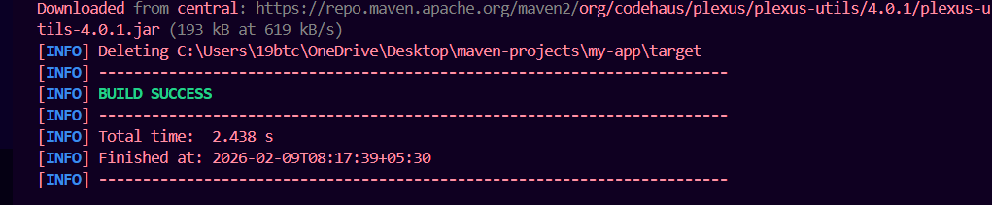

ii) mvn compile: We can compile application code (target folder)
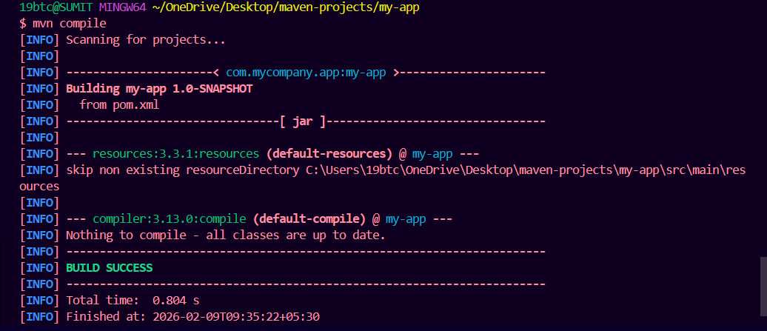

iii) mvn test: we can test our application code
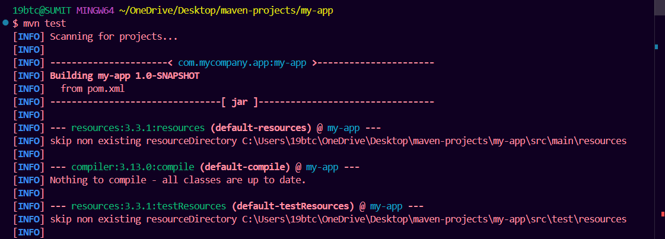
.
.
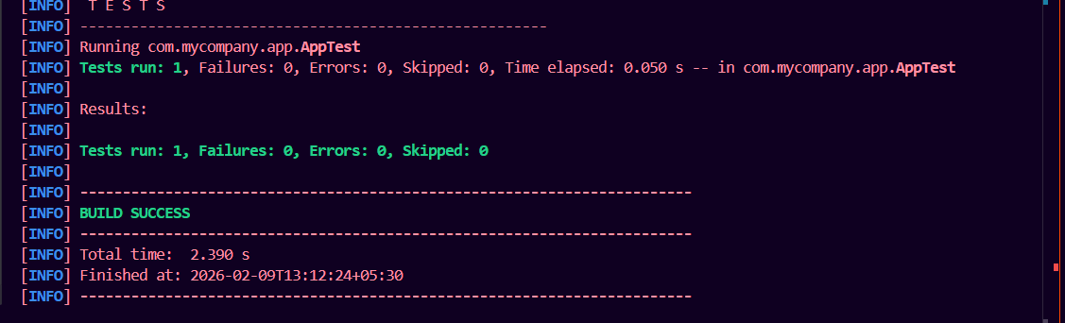

iv) mvn package : we can package our application code + dependencies



